I. Introduction

1.1 Project Context

Wealth Securities Inc. (WSI) has ranked among the top 20 brokerages in the Philippines since its incorporation in November 1986. The company caters to both retail and institutional clients in the Philippines and overseas. One of the important parts of their system is portfolio management. Portfolio management is the art and science of making decisions about investment and portfolio management system displays the necessary stock information for the client.

Mobile interaction is popularly used in online system and with that we could establish that there is a need to incorporate the portfolio management system into mobile devices to cope up with the advancement in technology.

1.2 Purpose and Description

Purpose

The purpose of the project is to create a mobile platform prototype for the portfolio management system of Wealth Securities Inc.

Description

This project would provide the following functionalities:

1. Quick access to client’s portfolio

2. Access to historical stock information

3. Chart generation

4. Device Flexibility

5. Increased end-user productivity

1.3 Objectives

The objective of this project is to create a portfolio management system that would allow the client to view their portfolio, view stock quotes, and view charts.

The proposed portfolio management system must be designed to provide a friendly interface for the client and must be designed to be compatible to desktop and mobile usage. As the list of problems unfolds, several common sources are likely to be discovered.

When trying to develop solutions, the team must look for the source of the problems. There are many cases of database systems that failed to satisfy the end-users because they are designed to treat the symptoms of the problems rather than their source. (Abuzo, 2015)

The team’s job is to make sure that the portfolio management corresponds to those envisioned by the end-users. In any case, the team must begin to address the following questions:

• What other functionalities that could be added to the system?

• Will the proposed system satisfy the needs of the company and its clients?

1.4 Scope and Limitations

The scope of this project is to create a prototype mobile platform for the portfolio management system of Wealth Securities Inc. Specifically the team will develop the viewing functionality of portfolio and stock quote; and Market interpretation through charts.

The proposed prototype of portfolio management system is also subject to boundaries known as "limits", which affects the systems functionality and performance. Specifically the system is limited to the stock quote information, and for the sample portfolio information given by Wealth Securities Inc. The system cannot generate or display information without the necessary data needed.

But unfortunately, in the real world, a system often must be designed around the client’s vision. Thus, the scope and limitations become the factors that force the design into specific mold, and the team's job is to design the best system possible within those constraints. (Abuzo, 2015)

Note that problem definitions and the objectives sometimes must be reshaped to meet the system scope and limitations.

## II. Review of Related Literature/Study

In ways similar to other companies, transaction is all the events that take place on a daily basis in an organization. Transaction processing system (TPS) is required to capture and process those transactions to update data on the fundamental operations of an organization. According to Mahajan, a professor of Information technology in Amity University, the essence of a transaction processing program is that it manages data that must be left in a consistent state. This type of integrity must always be provided to the data and transaction processing.  
Portfolio Management systems pioneered many concepts in distributed computing and fault-tolerance computing which introduced data for reliability, availability, and performance. Most importantly, they introduced the transaction ACID properties— atomicity, consistency, isolation, and durability (JGray and AReuter, 1992)  
  
According to the study conducted by International Business Times, it takes more than customer service and discounts. Investors look for mobile platforms to let them trade from anywhere, or sophisticated education resources to help them navigate tricky markets. They surveyed investors to find out the top online brokerage firms.  
  
Charles Schwab took the top spot in for trade reliability and research tools, but its top spot in Mobile Platform Trading distinguishes it from the rest of the list. Clients can use the Schwab Mobile app to view real-time market data, place trades and even watch a live stream of CNBC from their smartphone or tablet.  
  
Fidelity’s high rank is thanks to its top spot in the portfolio analysis and investment research categories. The Boston-based firm placed in the top five in nine out of 12 categories including equity trading tools, research tools and customer service. Investors can compare up to four stocks at a time using up to 147 different traits with Fidelity’s tools. About a quarter of the mutual funds and about 6 percent of the ETS are commission-free for online customers. 

Bloomberg app incorporated the mentioned properties of a transaction processing system and created a mobile platform for its users. It provides instant access to global business and finance news, market data and portfolio tracking tools. Local Companies just like FirstMetroSec, Philstocks, and Col Financials already made similar mobile application and web-based platform for their online brokerage firm.

Philstocks Mobile is the first and only online stock trading application officially reviewed by securities regulatory institutions it features an online trading platform that is suited for traders on-the-go, instant buying and selling of stocks, easy portfolio access, and latest feeds on market information from Philippines Stock Exchange (PSE).

Col Financials HTML5 mobile platform lets you access your trading account wherever you go. Trade stocks and options in real-time. Real-time streaming quotes. Access your account portfolio and transaction history at ease.

**Context diagram**

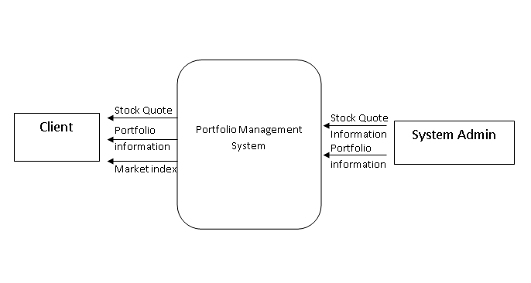

**DFD lvl 0**

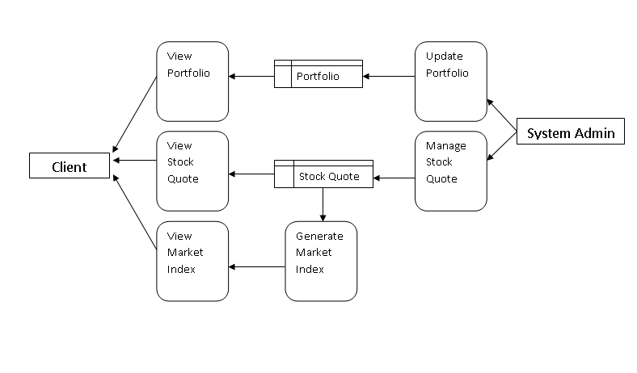

**ERD Diagram**

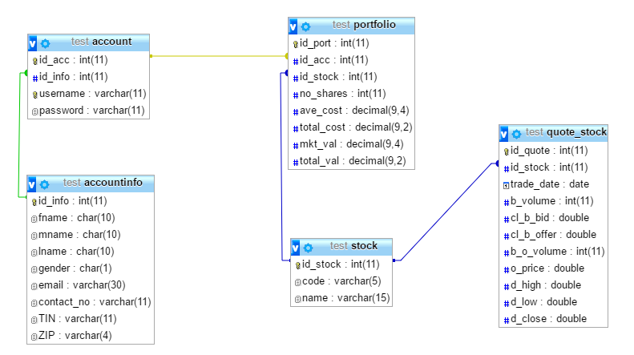

**Event Table**

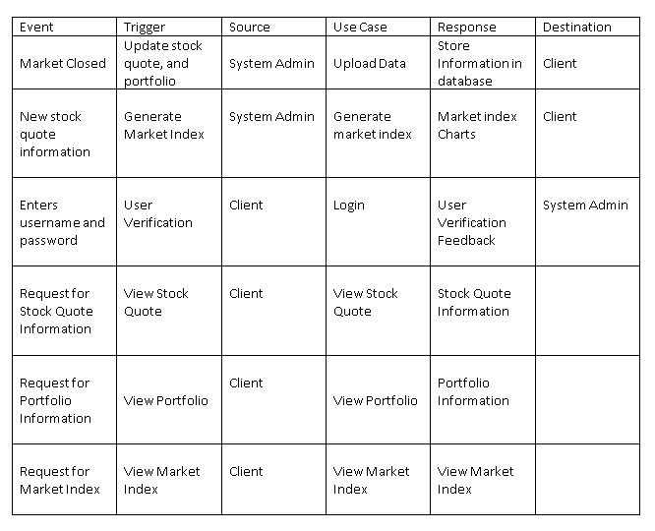

**Class Diagram**

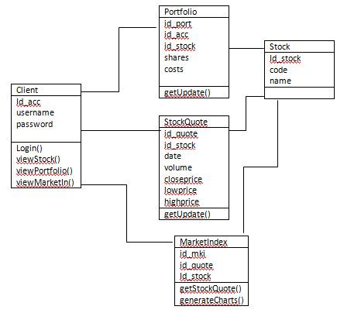

**Sequence diagram**

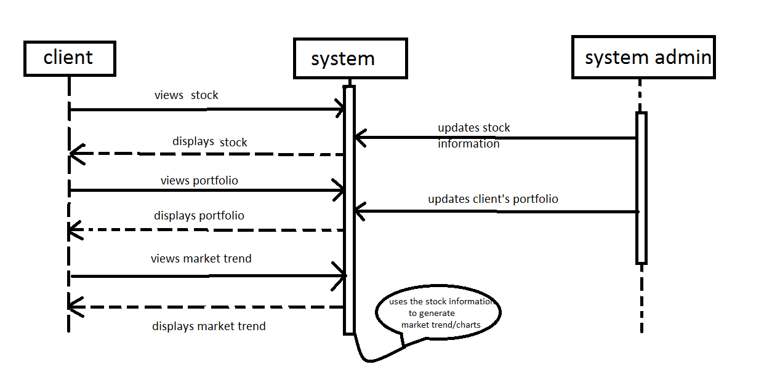

**Activity Diagram:**

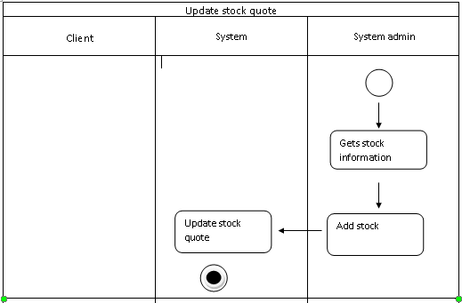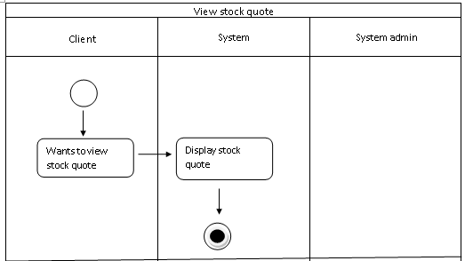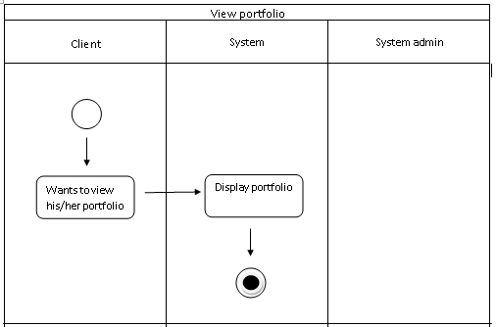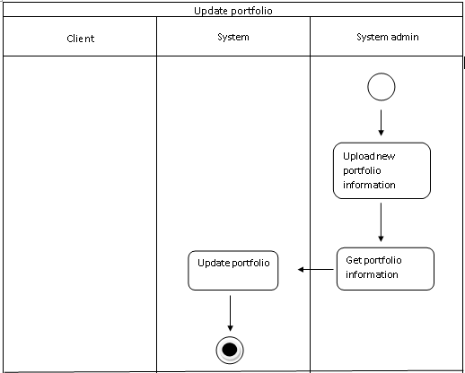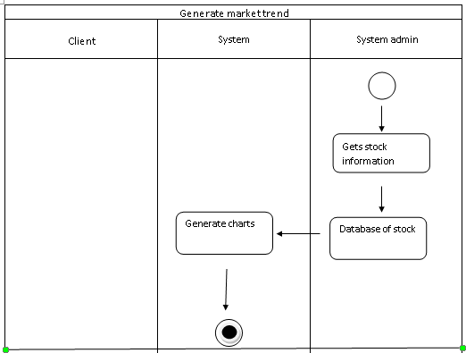

**Use case diagram**

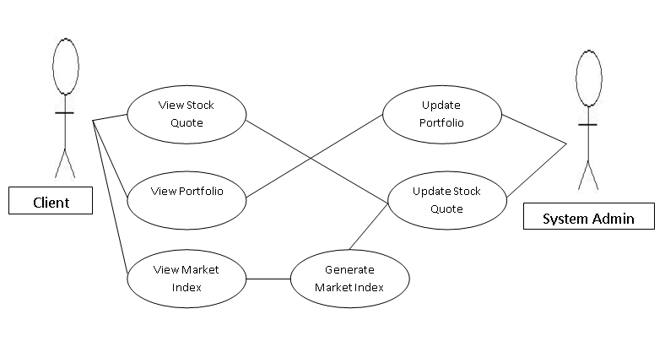

**Use case full description:**

|  |  |  |
| --- | --- | --- |
| Use Case Name: | View Stock Quote | |
| Scenario: | Client wants to view the stock quote | |
| Triggering Event: | View stock quote | |
| Brief Description: | Client sees the stock quote information | |
| Actors: | Client | |
| Related Use Cases: | Update Stock Quote | |
| Stakeholders: | Client | |
| Preconditions: | Client can view various available information to view. | |
| Postconditions: | Client checks bids and ask price, last-traded price and volume traded. | |
| Flow of Activities: | Actor | System |
| * Investor can select various available options to view the data. * The corresponding data is displayed on the screen | 1. System will allow to view the account of the investor. |
| Exception Conditions: | 1. The requested data may not be displayed because of the system crash or network problem. | |

|  |  |  |
| --- | --- | --- |
| Use Case Name: | View portfolio | |
| Scenario: | Investor is able to view his/her portfolio or different portfolio companies. | |
| Triggering Event: | Client checks his portfolio | |
| Brief Description: | Investor finishes his work and has to logout from the system to protect his account. | |
| Actors: | Client | |
| Related Use Cases: | Update portfolio | |
| Stakeholders: | Investor | |
| Preconditions: | Investor is logged into his/her account and selects the “view portfolio” option. | |
| Post conditions: | The portfolio of the company requested by the investor may not exist in the exchange service. | |
| Flow of Activities: | Actor | System |
| 1. Investor selects the “view portfolio” option.  2. The investor’s portfolio is displayed on the screen. | System will allow client to view the information of client |
| Exception Conditions: | 1. The company’s portfolio requested by the investor may not exist in the exchange service. | |

|  |  |  |
| --- | --- | --- |
| Use Case Name: | Update portfolio | |
| Scenario: | System admin is able to edit client’s portfolio | |
| Triggering Event: | Update portfolio | |
| Brief Description: | System admin will update the client’s portfolio | |
| Actors: | System Admin | |
| Related Use Cases: | View portfolio | |
| Stakeholders: | Client | |
| Preconditions: | System admin will update the portfolio whenever there’s an update in the stock quote. | |
| Postconditions: | The portfolio of the client requested by the client may not exist in the exchange service. | |
| Flow of Activities: | Actor | System |
| 1. System admin selects the “update portfolio” option.  2. The investor’s portfolio is displayed on the screen with the updated one. | System update information of client |
| Exception Conditions: |  | |

|  |  |  |
| --- | --- | --- |
| Use Case Name: | Update stock quote | |
| Scenario: | Investor is able to edit stock quote | |
| Triggering Event: | Update stock quote | |
| Brief Description: | Investor will update stock quote | |
| Actors: | Client | |
| Related Use Cases: | View stock quote | |
| Stakeholders: | Client | |
| Preconditions: | Investor is logged into his/her account and selects the “update stock quote” option. | |
| Postconditions: |  | |
| Flow of Activities: | Actor | System |
| 1. Investor selects the “update stock quote” option.  2. The investor’s stock quote is displayed on the screen with the updated one. | System update information stock quote of different companies |
| Exception Conditions: |  | |

|  |  |  |
| --- | --- | --- |
| Use Case Name: | View index market | |
| Scenario: | Investor is able to view market | |
| Triggering Event: | View index market | |
| Brief Description: | Investor will be able to view the index market | |
| Actors: | Client | |
| Related Use Cases: | Generate index market | |
| Stakeholders: | Client | |
| Preconditions: | Investor is logged into his/her account and selects the “view index market” option. | |
| Postconditions: | Investor sees the measurement of the stock market. | |
| Flow of Activities: | Actor | System |
| 1. Investor selects the “Index market” option.  2. The measurement of the value of a section of the stock market is displayed on the screen. | System will generate the computed prices of selected stocks using graphs. |
| Exception Conditions: |  | |

|  |  |  |
| --- | --- | --- |
| Use Case Name: | Generate index market | |
| Scenario: | Investor is able to generate index market | |
| Triggering Event: | Generate index market | |
| Brief Description: | Investor will be able to generate index market | |
| Actors: | Client | |
| Related Use Cases: | View index market | |
| Stakeholders: | Client | |
| Preconditions: | Investor is logged into his/her account and selects the “generate index market” option. | |
| Postconditions: | Investor sees the measurement of the stock market. | |
| Flow of Activities: | Actor | System |
| 1. Investor selects the “Index market” option.  2. Investor is logged into index market and selects “Generate index market” option.  3. The measurement of the value of a section of the stock market is displayed on the screen. | System will allow the client to generate the computed prices of selected stocks using graphs. |
| Exception Conditions: |  | |

**Communication diagram**

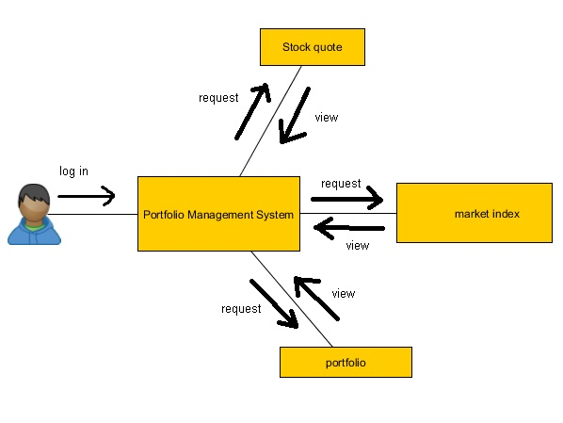

**Component diagram**

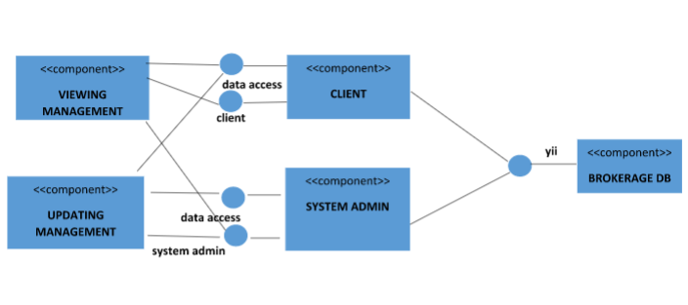

**Package diagram**

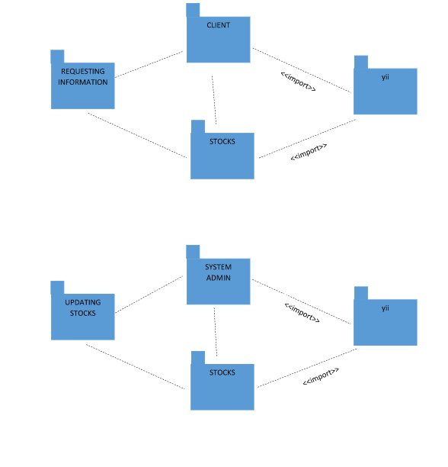

**State diagram**

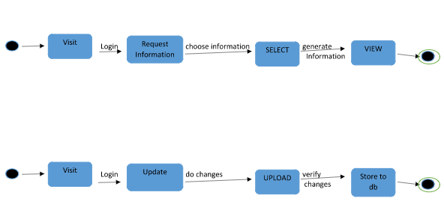

**Composite diagram**

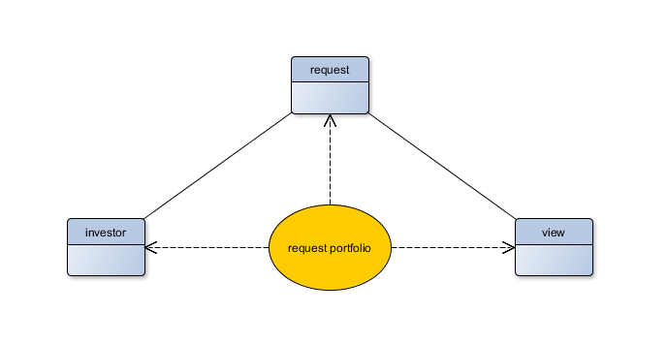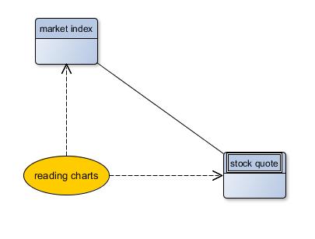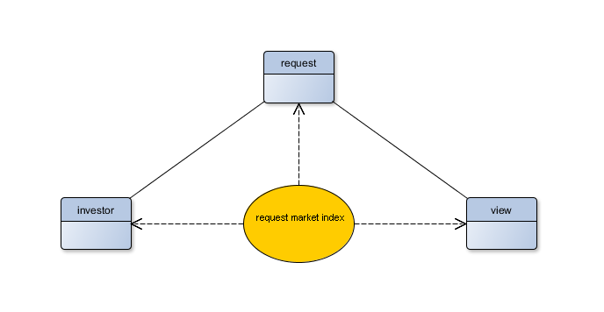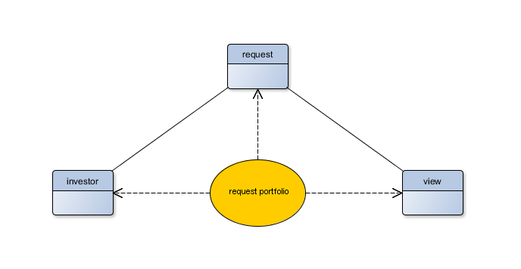

**Deployment diagram**

